1.Open file web api sample project

Run the file.see the scrrenshot attached after running the file.

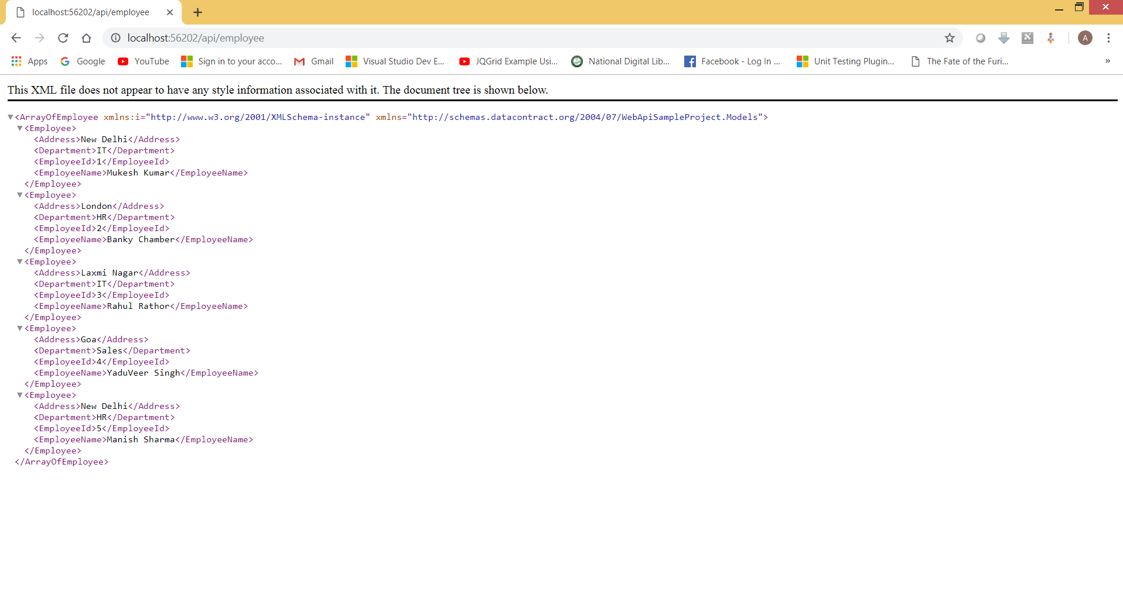

Open file named as ConsumingWebApi and run the file.Make ensure that web api sample project should be run first.

You will get the employee details as given below:

